Lab plan no.3 Name: Muhammad Faizan Reg No.21-NTU-CS-1258

# Question No 1

### Following is the code which will print next character which comes after the64in the ASCII table

### int x=64;x++;

### Same as x=x+1;cout<<"x="<<static_cast<char>(x);

## Input:

#include<iostream>

using namespace std;

int main()

{

int x;

cout<<"Input any character in integer form ";

cin>>x;

x++;

cout<<"x="<<static_cast<char>(x)<<endl;

x++;

cout<<"x="<<static_cast<char>(x)<<endl;

x++;

cout<<"x="<<static_cast<char>(x)<<endl;

x++;

cout<<"x="<<static_cast<char>(x)<<endl;

x++;

cout<<"x="<<static_cast<char>(x);

return 0;

}

Output: 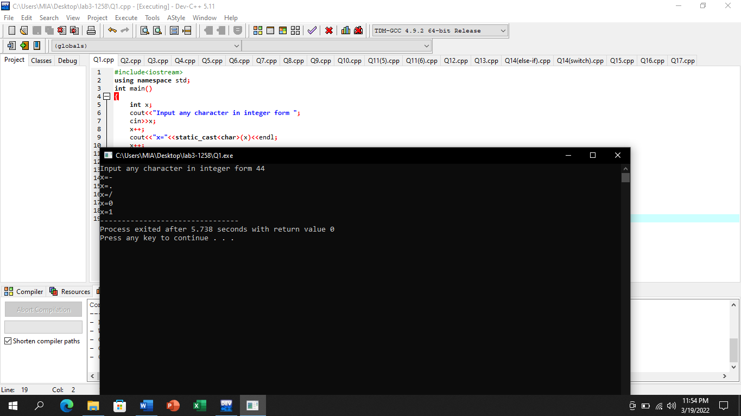

# Question No 2

### Ask the user to enter radius of the circle and print diameter, circumference and area of the circle.

### Declare the value of piasconst float pi = 3.14159;

### Please note in this statementpiis aconstant value variable whose value cannot be changed

## Input:

#include<iostream>

using namespace std;

int main()

{

float radius,diameter,circumference,area;

const float pi=3.14159;

cout<<"Input radius of a circle ";

cin>>radius;

diameter=2*radius;

cout<<"Diameter of circle is "<<diameter<<endl;

circumference=2*pi*radius;

cout<<"Circumference of circle is "<<circumference<<endl;

area=pi*radius*radius;

cout<<"Area of circle is "<<area<<endl;

return 0;

}

## Output:

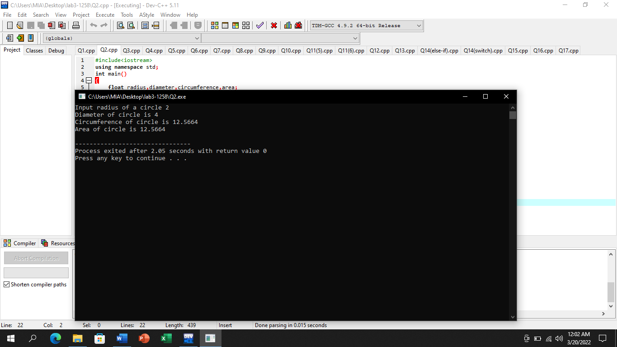

# Question No 3

### Ask the user to enter the distance in Kilometers and convert it into meters, feet, yards and miles.

### Print appropriately One Kilometer = 0.621371192 Miles, 1000 Meters, 1093.6133 yards, 3280.8399 feet

## Input:

#include<iostream>

using namespace std;

int main()

{

float kilometer,meters,feet,yards,miles;

cout<<"Enter distance in kilometer ";

cin>>kilometer;

meters=kilometer*1000;

cout<<"Distance in meters is "<<meters<<endl;

feet=kilometer*3280.8399;

cout<<"Distance in feet is "<<feet<<endl;

yards=kilometer*1093.6133;

cout<<"Distance in yards is "<<yards<<endl;

miles=kilometer*0.621371192;

cout<<"Distance in miles is "<<miles<<endl;

return 0;

}

## Output:

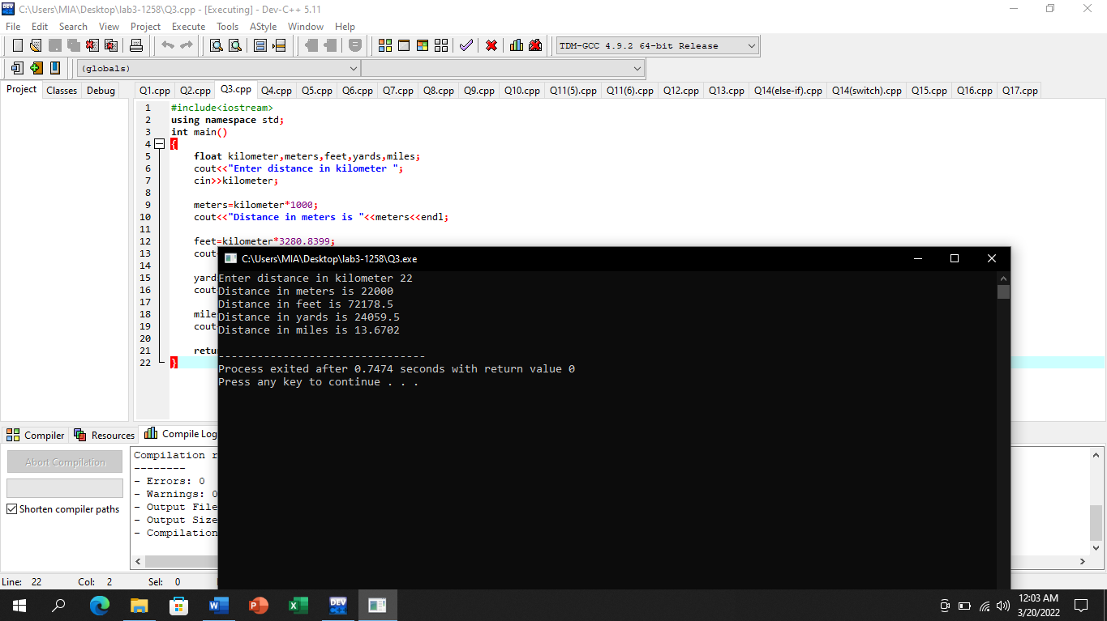

# Question No 4

### size of operator show size of datatype in bytes i.e. cout<<”Size of int =”<<sizeof(int); Show size of bool, short, float, double

## Input:

#include<iostream>

using namespace std;

int main()

{

cout<<"Size of bool = "<<sizeof(bool)<<" byte"<<endl;

cout<<"Size of short = "<<sizeof(short)<<" bytes"<<endl;

cout<<"Size of float = "<<sizeof(float)<<" bytes"<<endl;

cout<<"Size of double = "<<sizeof(double)<<" bytes"<<endl;

return 0;

}

## Output:

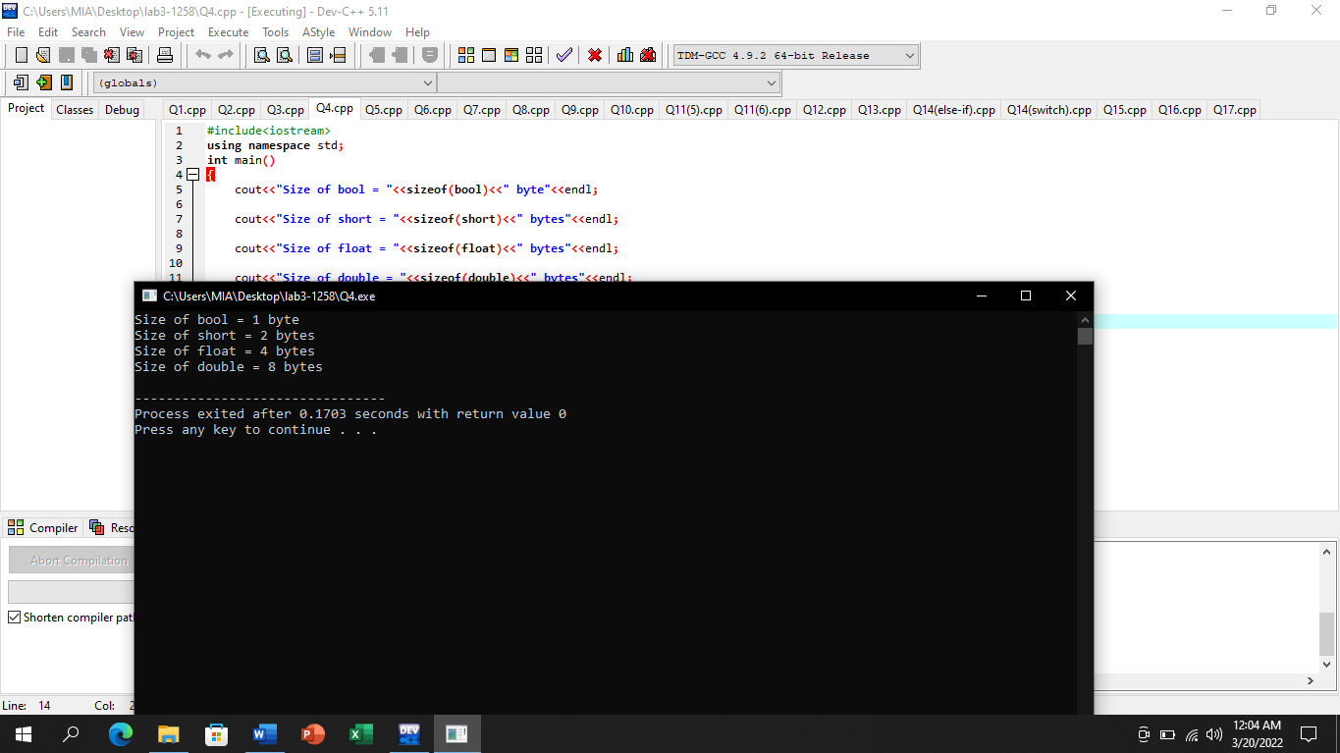

# Question No 5

### Take two integers from the user and check whether first is multiple of second

## Input:

#include<iostream>

using namespace std;

int main()

{

int num_1,num_2;

cout<<"Enter first integers ";

cin>>num_1;

cout<<"Enter second integer ";

cin>>num_2;

if(num_1%num_2==0)

{

cout<<num_1<<" is multiple of "<<num_2<<endl;

}

if(num_1%num_2!=0)

{

cout<<num_1<<" is not a multiple of "<<num_2;

}

return 0;

}

## Output:

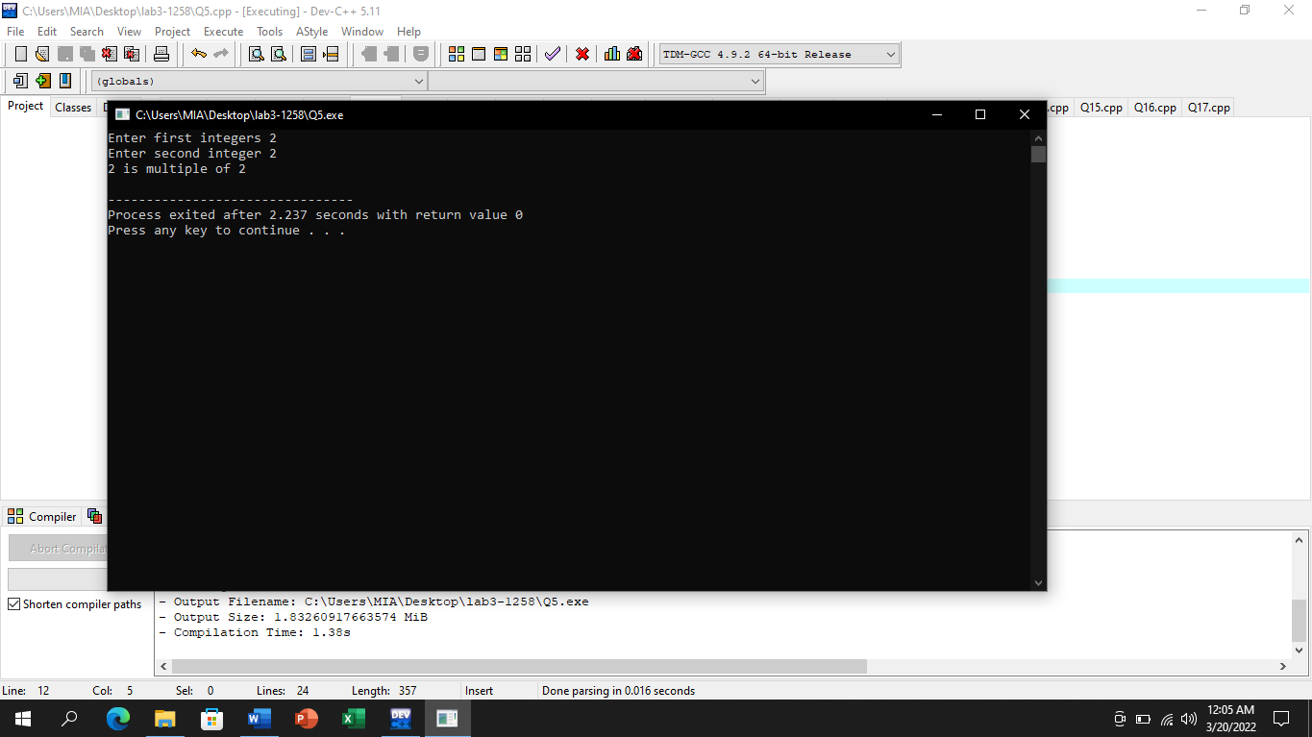

# Question No 6

### Ask the user to enter two numbers, and show number followed by “is larger.” OR “is Smaller” OR “Equal”

## Input:

#include<iostream>

using namespace std;

int main()

{

int num_1,num_2;

cout<<"Enter first number ";

cin>>num_1;

cout<<"Enter second number ";

cin>>num_2;

if(num_1>num_2)

{

cout<<num_1<<" is greater than "<<num_2;

}

if(num_1<num_2)

{

cout<<num_1<<" is less than "<<num_2;

}

if(num_1==num_2)

{

cout<<num_1<<" is equal to "<<num_2;

}

return 0;

}

Output:

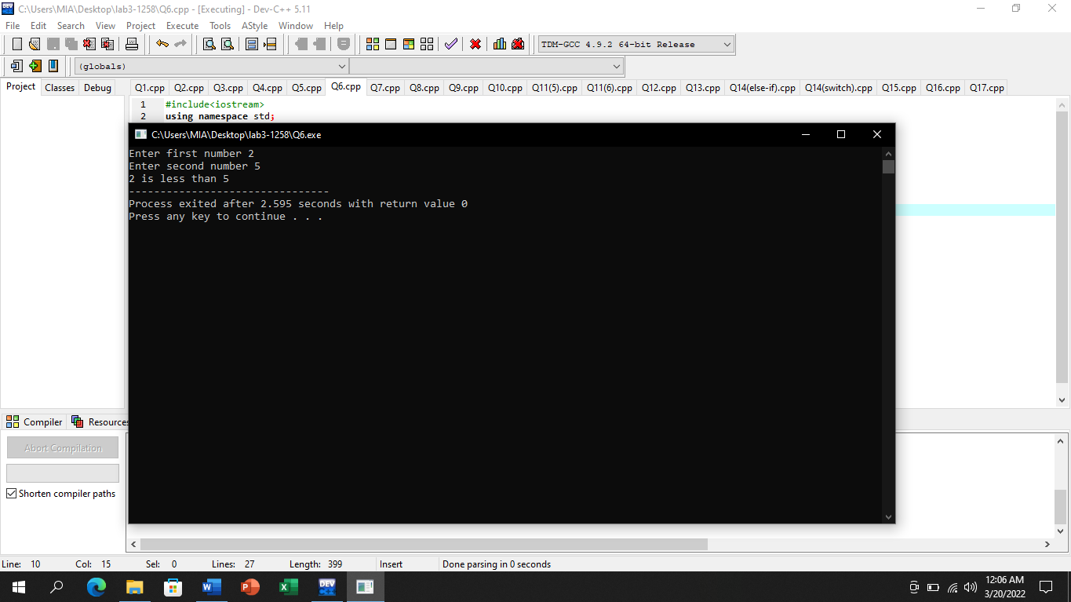

# Question No 7

### Input five integers from user and display minimum and maximum

## Input:

#include<iostream>

using namespace std;

int main()

{

float num_1,num_2,num_3,num_4,num_5;

cout<<"Input first integer ";

cin>>num_1;

cout<<"Input second integer ";

cin>>num_2;

cout<<"Input third integer ";

cin>>num_3;

cout<<"Input fourth integer ";

cin>>num_4;

cout<<"Input fifth integer ";

cin>>num_5;

if(num_1>num_2&&num_1>num_3&&num_1>num_4&&num_1>num_5)

{

cout<<num_1<<" is maximum";

}

if(num_2>num_1&&num_2>num_3&&num_2>num_4&&num_2>num_5)

{

cout<<num_2<<" is maximum";

}

if(num_3>num_1&&num_3>num_2&&num_3>num_4&&num_3>num_5)

{

cout<<num_3<<" is maximum";

}

if(num_4>num_1&&num_4>num_2&&num_4>num_3&&num_4>num_5)

{

cout<<num_4<<" is maximum";

}

if(num_5>num_1&&num_5>num_2&&num_5>num_3&&num_5>num_4)

{

cout<<num_5<<" is maximum"<<endl;

}

if(num_1<num_2&&num_1<num_3&&num_1<num_4&&num_1<num_5)

{

cout<<num_1<<" is minimum";

}

if(num_2<num_1&&num_2<num_3&&num_2<num_4&&num_2<num_5)

{

cout<<num_2<<" is minimum";

}

if(num_3<num_1&&num_3<num_2&&num_3<num_4&&num_3<num_5)

{

cout<<num_3<<" is minimum";

}

if(num_4<num_1&&num_4<num_2&&num_4<num_3&&num_4<num_5)

{

cout<<num_4<<" is minimum";

}

if(num_5<num_1&&num_5<num_2&&num_5<num_3&&num_5<num_4)

{

cout<<num_5<<" is minimum";

}

return 0;

}

## Output:

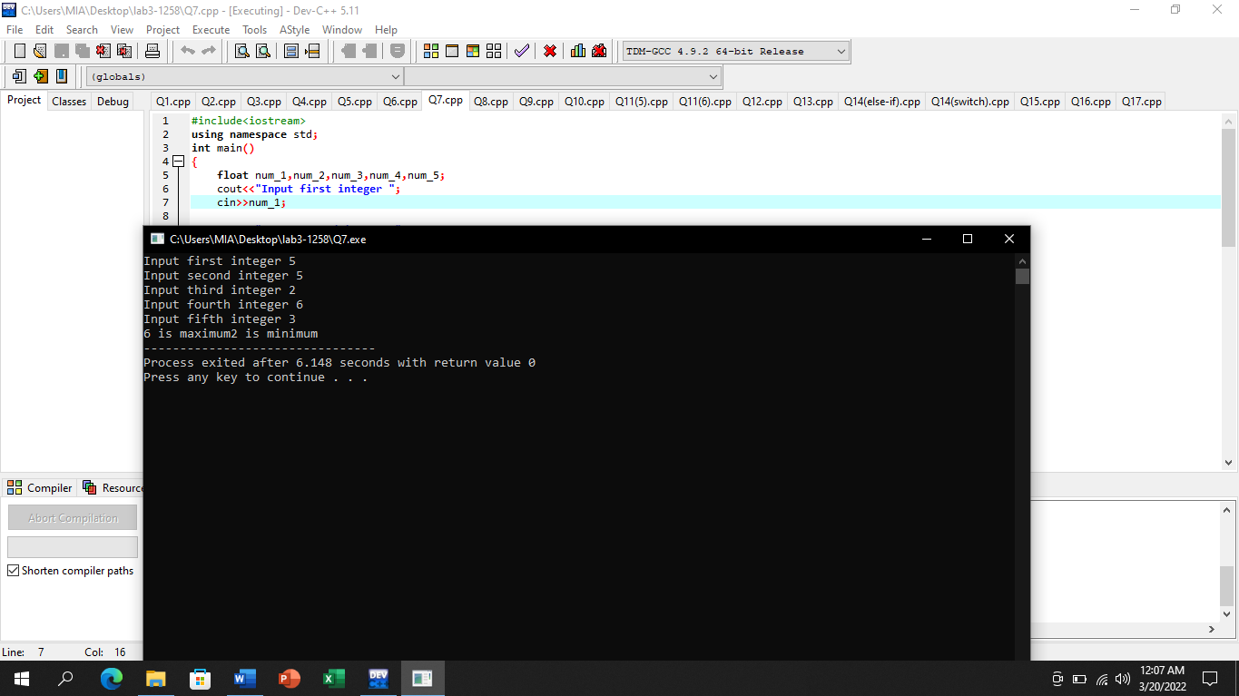

# Question No 8

### Ask user to enter a character and tell whether it is large(>=’A’ and <=’Z’) alphabet or small alphabet

Input:

#include<iostream>

using namespace std;

int main()

{

char character;

cout<<"Enter any character ";

cin>>character;

if(character>='A'and character<='Z')

{

cout<<"The given character is large alphabet";

}

if(character>='a'and character<='z')

{

cout<<"The given character is small alphabet";

}

return 0;

}

## Output:

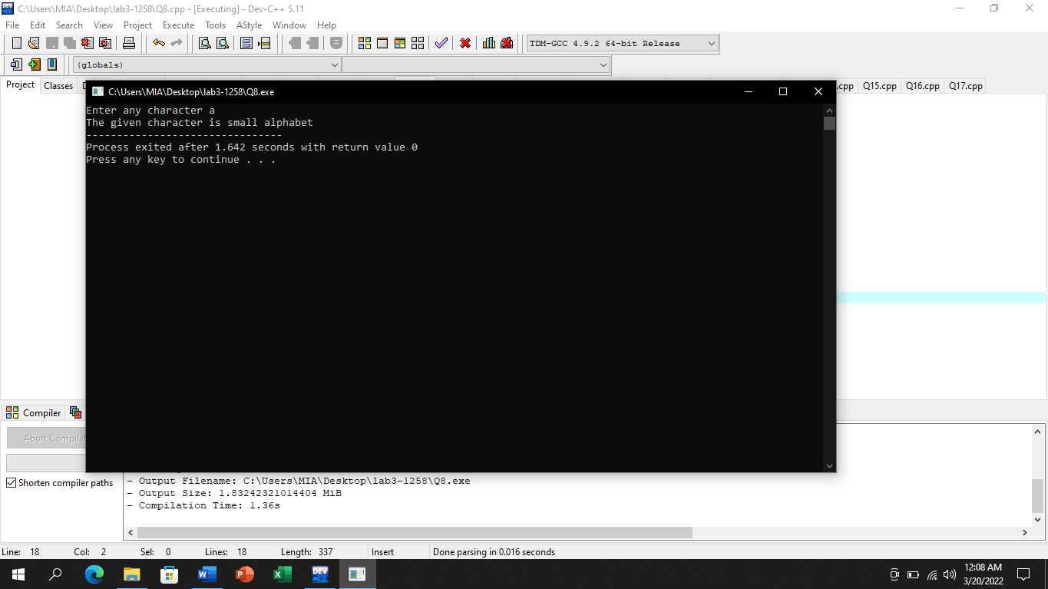

# Question No 9

### (Body Mass Index Calculator)

### Following is formula to calculate BMI:BMI= weight In Kilograms / (heightInMeters2).

### User will enter his weight in Kilograms and height in meters and the BMI of the userand display following?

### Display “You are Underweight” if BMI is less than 18.5?

### Display “You are Normal” if BMI is between18.5 and 24.9?

### Display “You are Overweight” if BMI is between 25 and 29.9?

### Display “You are Obese” If BMI is greater than 30

### Use And (&&) operator for writing multiple conditions in the if statement

## Input:

#include<iostream>

using namespace std;

int main()

{

float weight,height,BMI;

cout<<"Enter your height in meters ";

cin>>height;

cout<<"Enter your weight in kilogram ";

cin>>weight;

BMI=weight/(height*height);

if(BMI<18.5)

{

cout<<"You are Underweight"<<endl;

}

if((BMI>18.5) && (BMI<=24.9))

{

cout<<"You are Normal"<<endl;

}

if((BMI>25) && (BMI<=29.9))

{

cout<<"You are Overweight"<<endl;

}

if(BMI>30)

{

cout<<"You are Obese"<<endl;

}

return 0;

}

## Output:

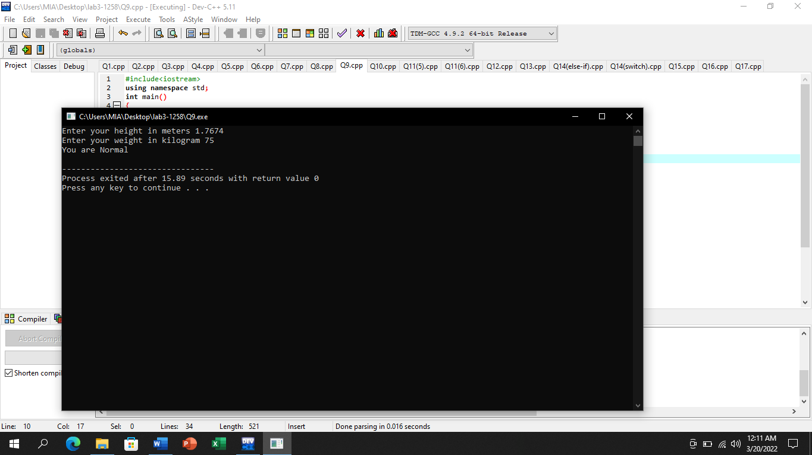

# Question No 10

### Ask the user to enter his marks in the Programming course,

### if the marks are greater than equal to 60 then display a message “He is Passed in the course”

### otherwise, display message: “He is Failed

## Input:

#include<iostream>

using namespace std;

int main()

{

int marks;

cout<<"Input your marks in Programming course ";

cin>>marks;

if(marks>=60)

{

cout<<"He is passed in the course"<<endl;

}

else

{

cout<<"He is Failed";

}

return 0;

}

## Output:

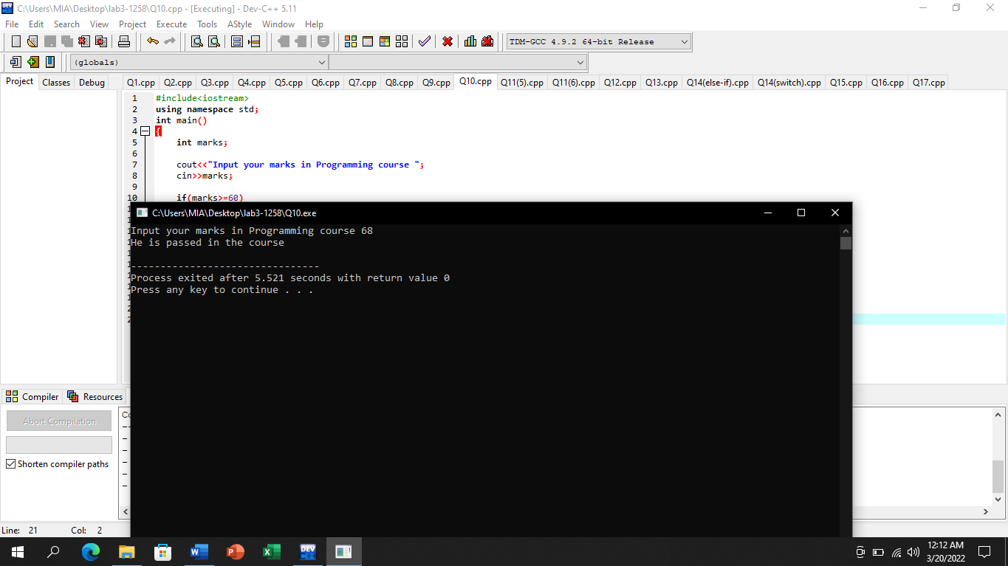

# Question No 11

### Solve QuestionNo.5, 6using if-else

## (5)

## Input:

//Question No 5 using if-else

#include<iostream>

using namespace std;

int main()

{

int num_1,num_2;

cout<<"Enter first integers ";

cin>>num_1;

cout<<"Enter second integer ";

cin>>num_2;

if(num_1%num_2==0)

{

cout<<num_1<<" is multiple of "<<num_2<<endl;

}

else

{

cout<<num_1<<" is not a multiple of "<<num_2;

}

return 0;

}

## Output:

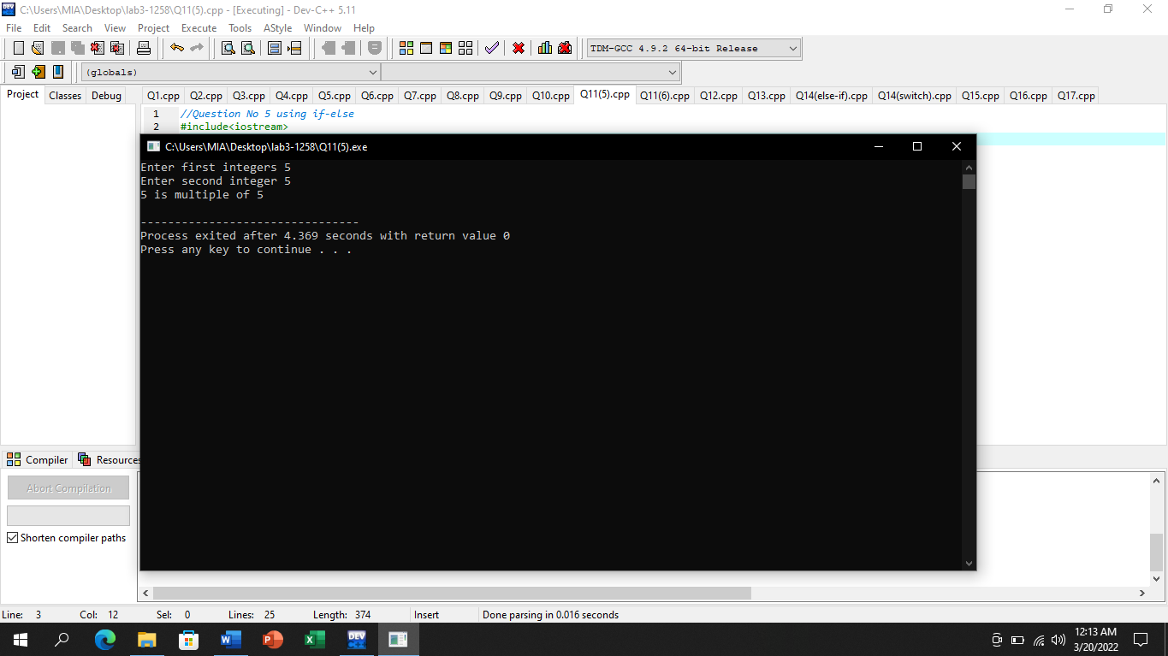

## (6)

## Input:

//Question No 6 using if-else

#include<iostream>

using namespace std;

int main()

{

int num_1,num_2;

cout<<"Enter first number ";

cin>>num_1;

cout<<"Enter second number ";

cin>>num_2;

if(num_1>num_2)

{

cout<<num_1<<" is greater than "<<num_2;

}

else if(num_1<num_2)

{

cout<<num_1<<" is less than "<<num_2;

}

else

{

cout<<num_1<<" is equal to "<<num_2;

}

return 0;

}

## Output:

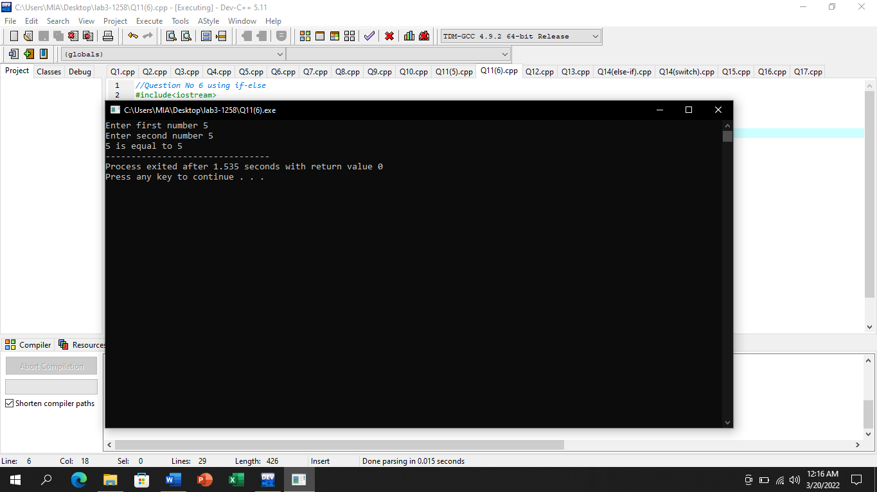

# Question No 12

### If a year is divisible by 4 then this is a Leap Year. Input year and tell whether it a Leap Year or not

## Input:

#include<iostream>

using namespace std;

int main()

{

int year;

cout<<"Input year ";

cin>>year;

if(year/4)

{

cout<<"This is Leap Year"<<endl;

}

else

{

cout<<"This is not Leap year";

}

return 0;

}

## Output:

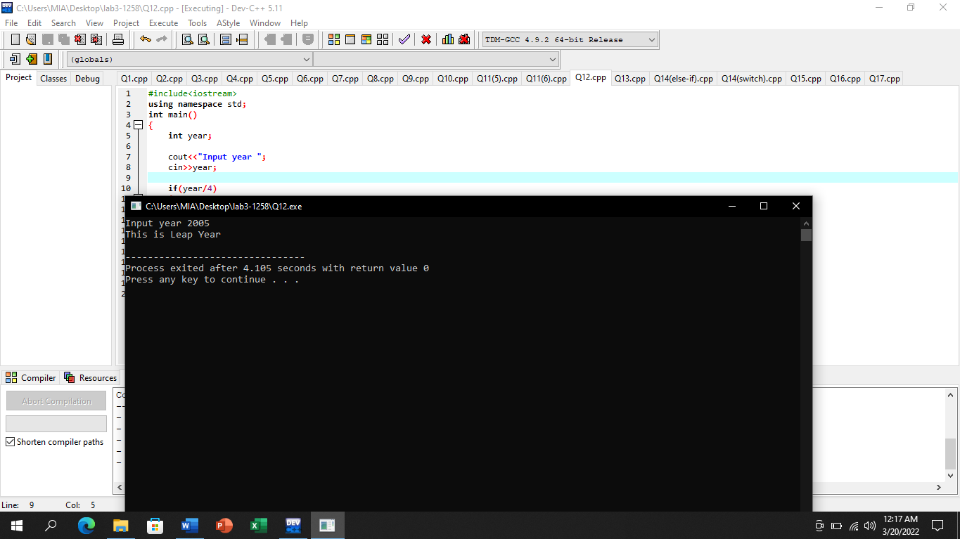

# Question No 13

### Ask the user to enter his\her marks and display his grade

## Input:

#include<iostream>

using namespace std;

int main()

{

int marks;

cout<<"Enter your Marks ";

cin>>marks;

if((marks>=90)&&(marks<=100))

{

cout<<"Your grade is A+";

}

else if((marks>=80)&&(marks<=89))

{

cout<<"Your grade is A";

}

else if((marks>=70)&&(marks<=79))

{

cout<<"Your grade is B";

}

else if((marks>=60)&&(marks<=69))

{

cout<<"Your grade is C";

}

else if((marks>=50)&&(marks<=59))

{

cout<<"Your grade is D";

}

if((marks>=0)&&(marks<=49))

{

cout<<"Your grade is F";

}

return 0;

}

## Output:

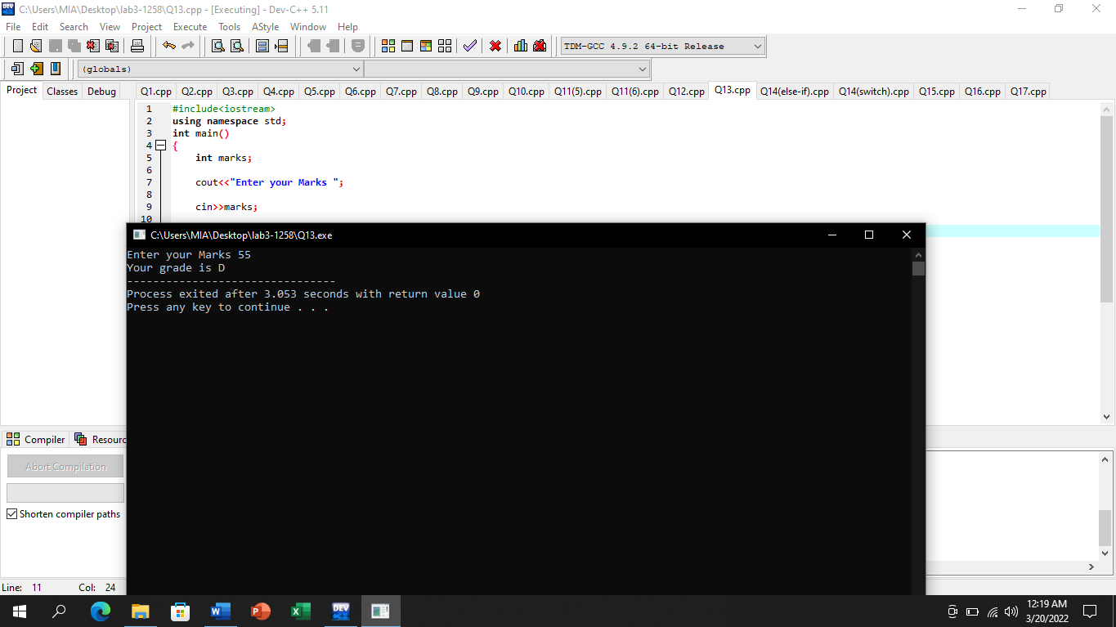

# Question No 14

### Solve the two integer calculator problem for operators (*,-, +, /,% ) using else-If and switch

# (else-if)

## Input:

#include<iostream>

using namespace std;

int main()

{

int num_1,num_2;

char op;

cout<<"Input first integer ";

cin>>num_1;

cout<<"Input second integer ";

cin>>num_2;

cout<<"Enter the operator ";

cin>>op;

if(op=='*')

{

cout<<num_1<<"*"<<num_2<<"="<<num_1*num_2<<endl;

}

else if(op=='-')

{

cout<<num_1<<"-"<<num_2<<"="<<num_1-num_2<<endl;

}

else if(op=='+')

{

cout<<num_1<<"+"<<num_2<<"="<<num_1+num_2<<endl;

}

else if(op=='/')

{

cout<<num_1<<"/"<<num_2<<"="<<num_1/num_2<<endl;

}

else if(op=='%')

{

cout<<num_1<<"%"<<num_2<<"="<<num_1%num_2;

}

else

{

cout<<"Please enter a valid operator";

}

}

## Output:

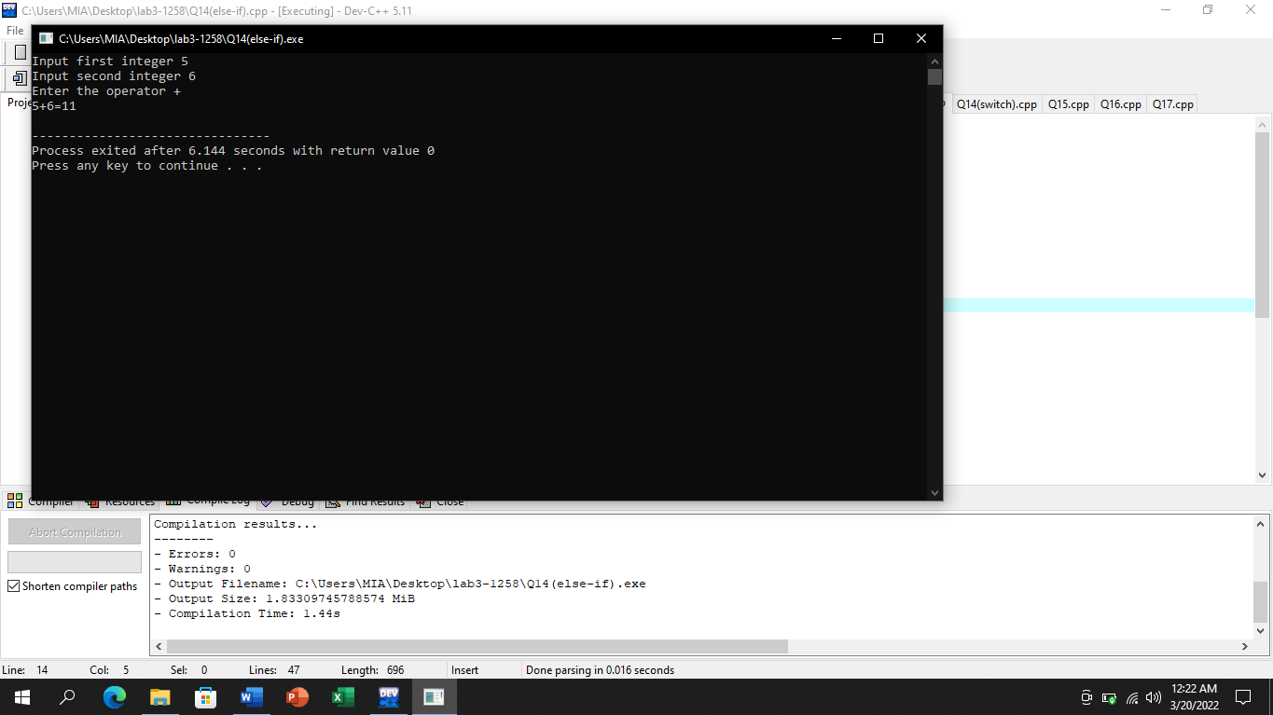

# (switch)

## Input:

#include<iostream>

using namespace std;

int main()

{

int num_1,num_2;

char op;

cout<<"Input first integer ";

cin>>num_1;

cout<<"Input second integer ";

cin>>num_2;

cout<<"Enter the operator ";

cin>>op;

switch(op)

{

case '*':

cout<<num_1<<"*"<<num_2<<"="<<num_1*num_2<<endl;

break;

case '-':

cout<<num_1<<"-"<<num_2<<"="<<num_1-num_2<<endl;

break;

case '+':

cout<<num_1<<"+"<<num_2<<"="<<num_1+num_2<<endl;

break;

case '/':

cout<<num_1<<"/"<<num_2<<"="<<num_1/num_2<<endl;

break;

case '%':

cout<<num_1<<"%"<<num_2<<"="<<num_1%num_2<<endl;

break;

default:

cout<<"You have entered invalid operator";

}

}

## Output:

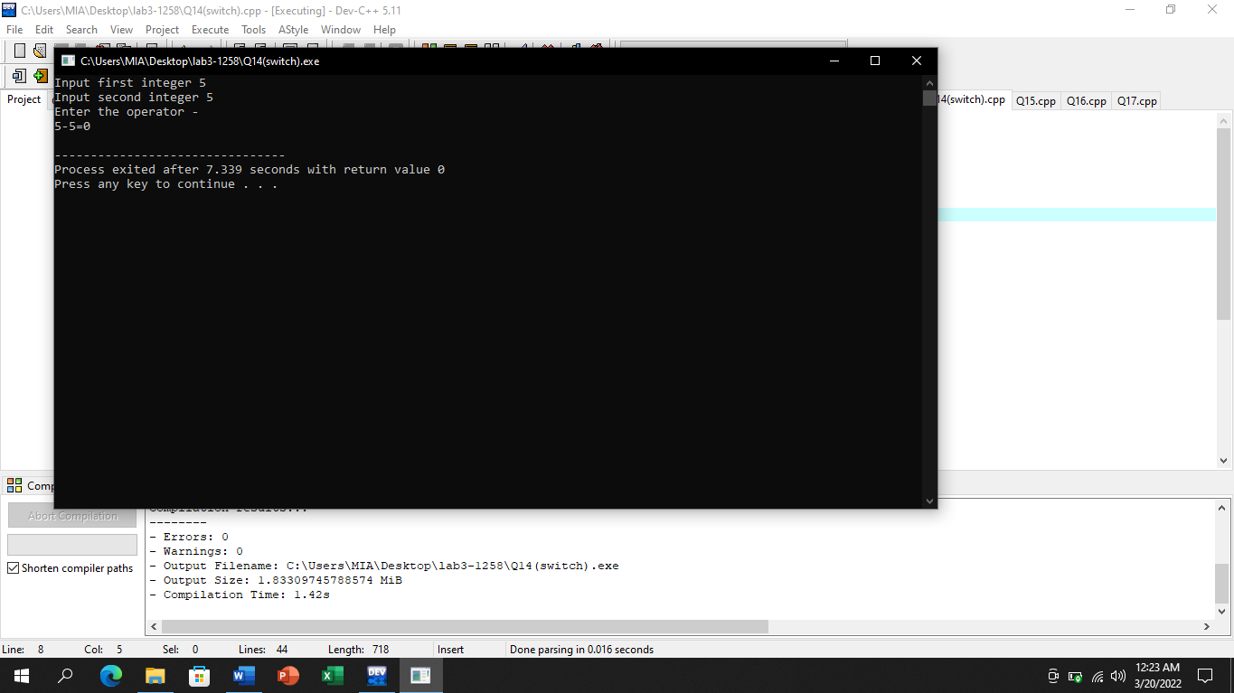

# Question No 15

### Input a vowel (a, e, I, o, u) and display any word starting from this vowel i.e. if user enter o display Operator

## Input:

#include<iostream>

using namespace std;

int main()

{

char vowel;

cout<<"Enter any vowel ";

cin>>vowel;

if((vowel=='a')||(vowel=='A'))

{

cout<<vowel<<" for Apple "<<endl;

}

else if((vowel=='e')||(vowel=='E'))

{

cout<<vowel<<" for Elephant "<<endl;

}

else if((vowel=='i')||(vowel=='I'))

{

cout<<vowel<<" for Internet "<<endl;

}

else if((vowel=='o')||(vowel=='O'))

{

cout<<vowel<<" for Output "<<endl;

}

else if((vowel=='u')||(vowel=='U'))

{

cout<<vowel<<" for Uniform ";

}

else

{

cout<<"Please enter a vowel";

}

return 0;

}

## Output:

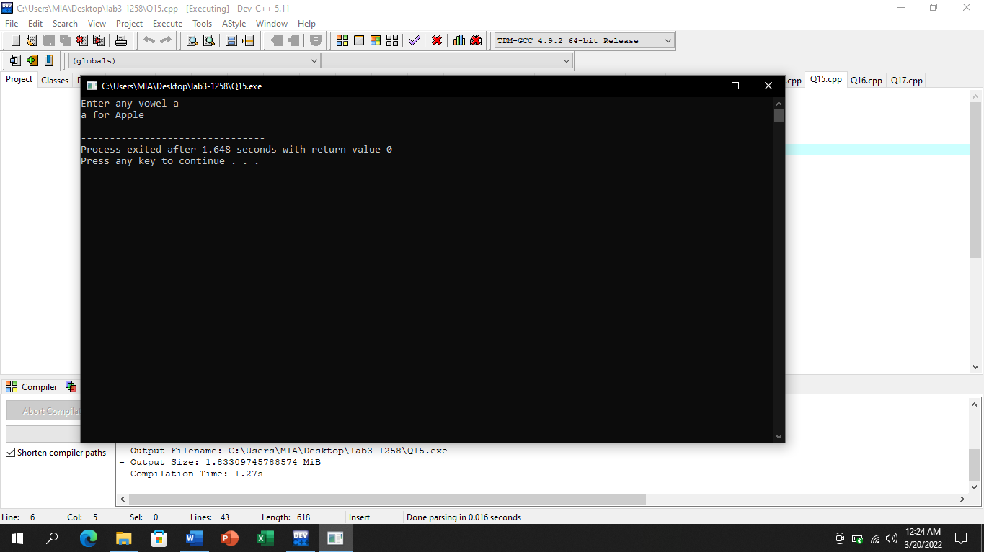

# Question No 16

### A senior salesperson is paid $800 a week, and a junior salesperson, $500 a week. Input a salesperson’s status (S for Senior, J for Junior )and number of weeks. Display relevant salary

## Input:

#include<iostream>

using namespace std;

int main()

{

int weeks;

char post;

cout<<"Enter number of weeks ";

cin>>weeks;

cout<<"Enter Post ";

cin>>post;

if(post=='J')

{

cout<<"The salary is "<<weeks*500<<"$"<<endl;

}

else if(post=='S')

{

cout<<"The salary is "<<weeks*800<<"$"<<endl;

}

else

{

cout<<"Please enter a valid post.";

}

return 0;

}

## Output:

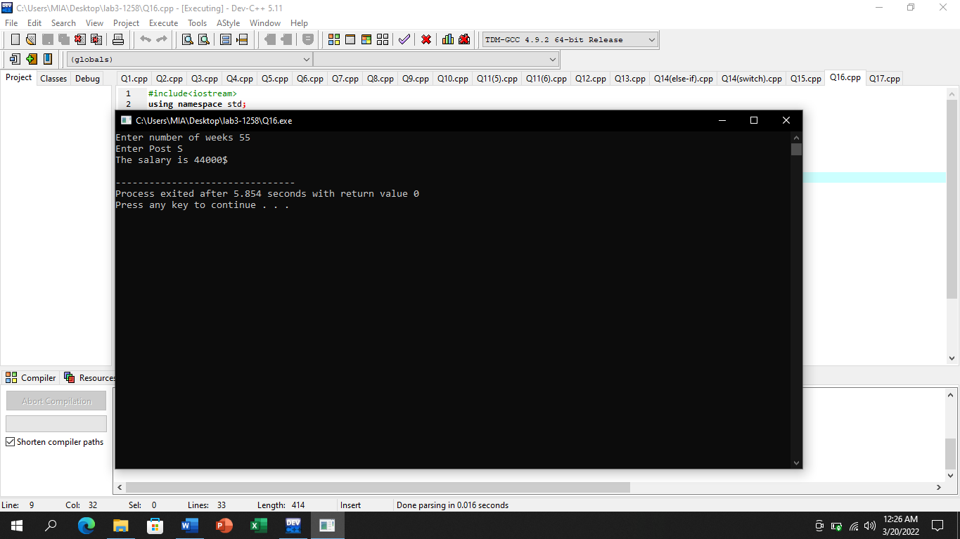

# Question No 17

### Write a code which check; student is eligible to get scholarship if his CGPA >= 3.5 if he is male and >=3 if she is female.

## Input:

#include<iostream>

using namespace std;

int main()

{

float CGPA;

char gender;

cout<<"Enter your CGPA ";

cin>>CGPA;

cout<<"Enter your Gender ";

cin>>gender;

if((gender=='m')&&(CGPA>=3.5))

{

cout<<"Congrats! You are eligible for scholorship.";

}

else if((gender=='f')&&(CGPA>=3))

{

cout<<"Congrats! You are eligible for scholorship.";

}

else

{

cout<<"You are not eligible for scholorship.";

}

return 0;

}

## Output:

